**Final Assignment 2023 – Utility Bill Platform**

**1) Login** - User will be able to login to the application with employee ID and OTP.

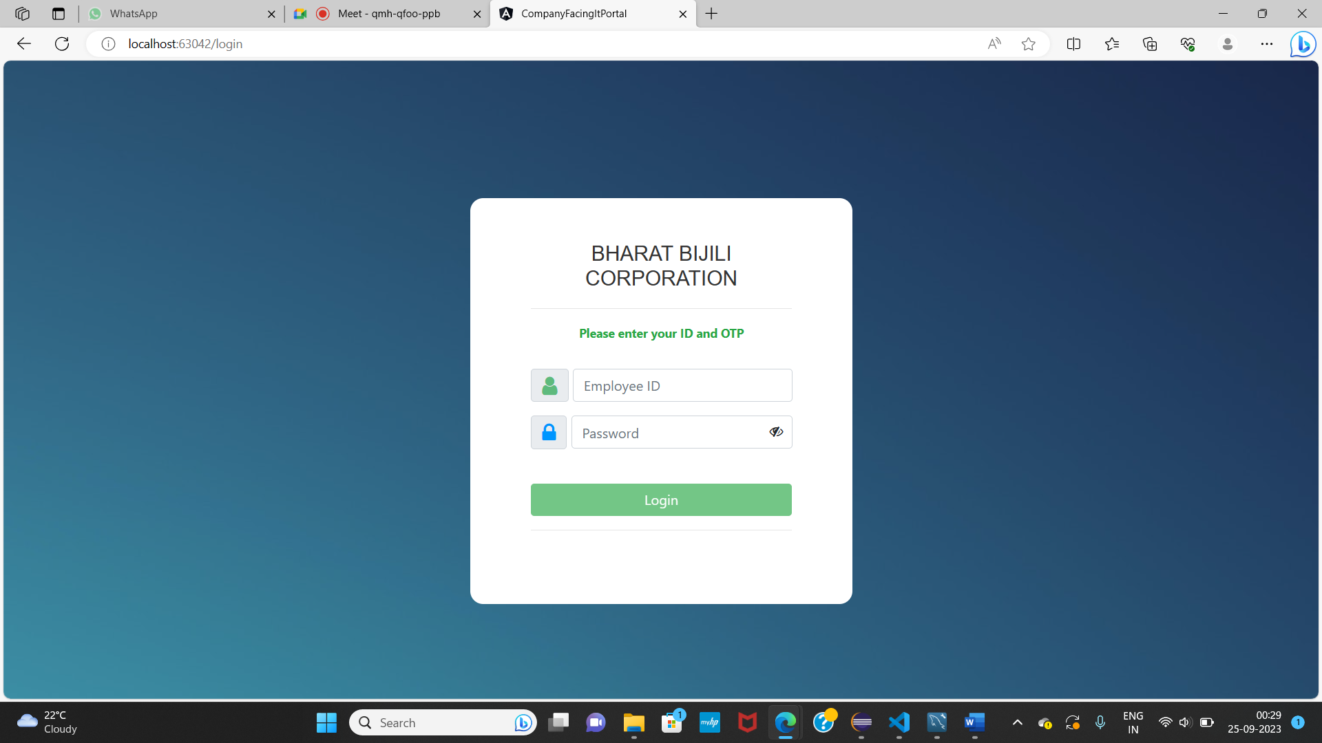

Employee Input Validation for employee id and password. Only after proper validated input the login option will be enabled.

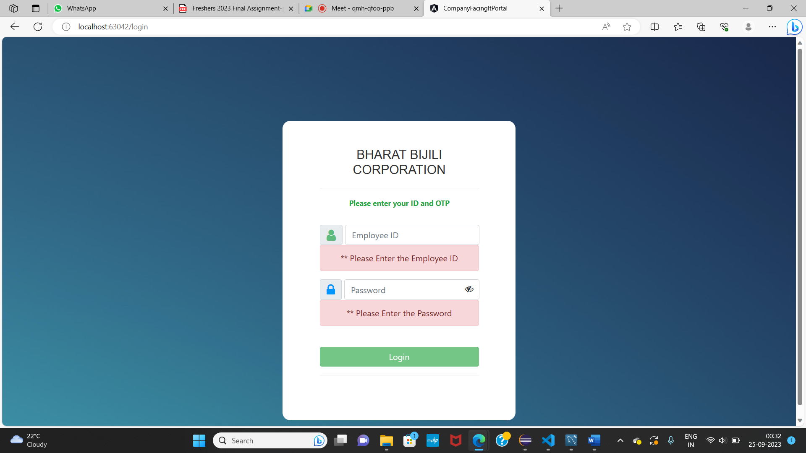

**2) Customer data management**

**a. Manual Customer Data Entry** - Users will be able to manually add customer information, including Name, Customer ID, Unit Consumption, Duration of bill by month/date range, Bill due date, Email, and Telephone number.

**b. Bulk Customer Data Upload**

- Users have the option to bulk upload a comma CSV file containing customer data with fields

(Name, Customer ID, Unit Consumed, Bill due date, Email, Telephone).

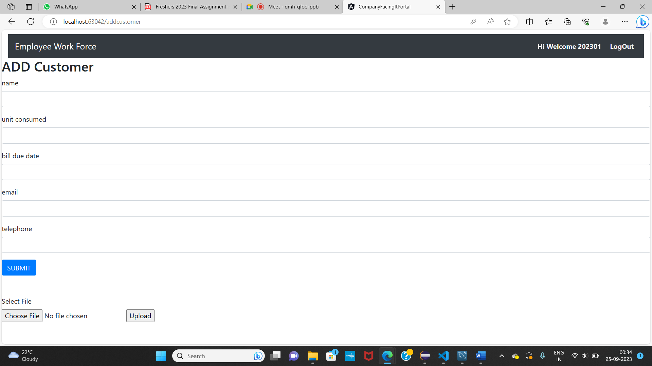

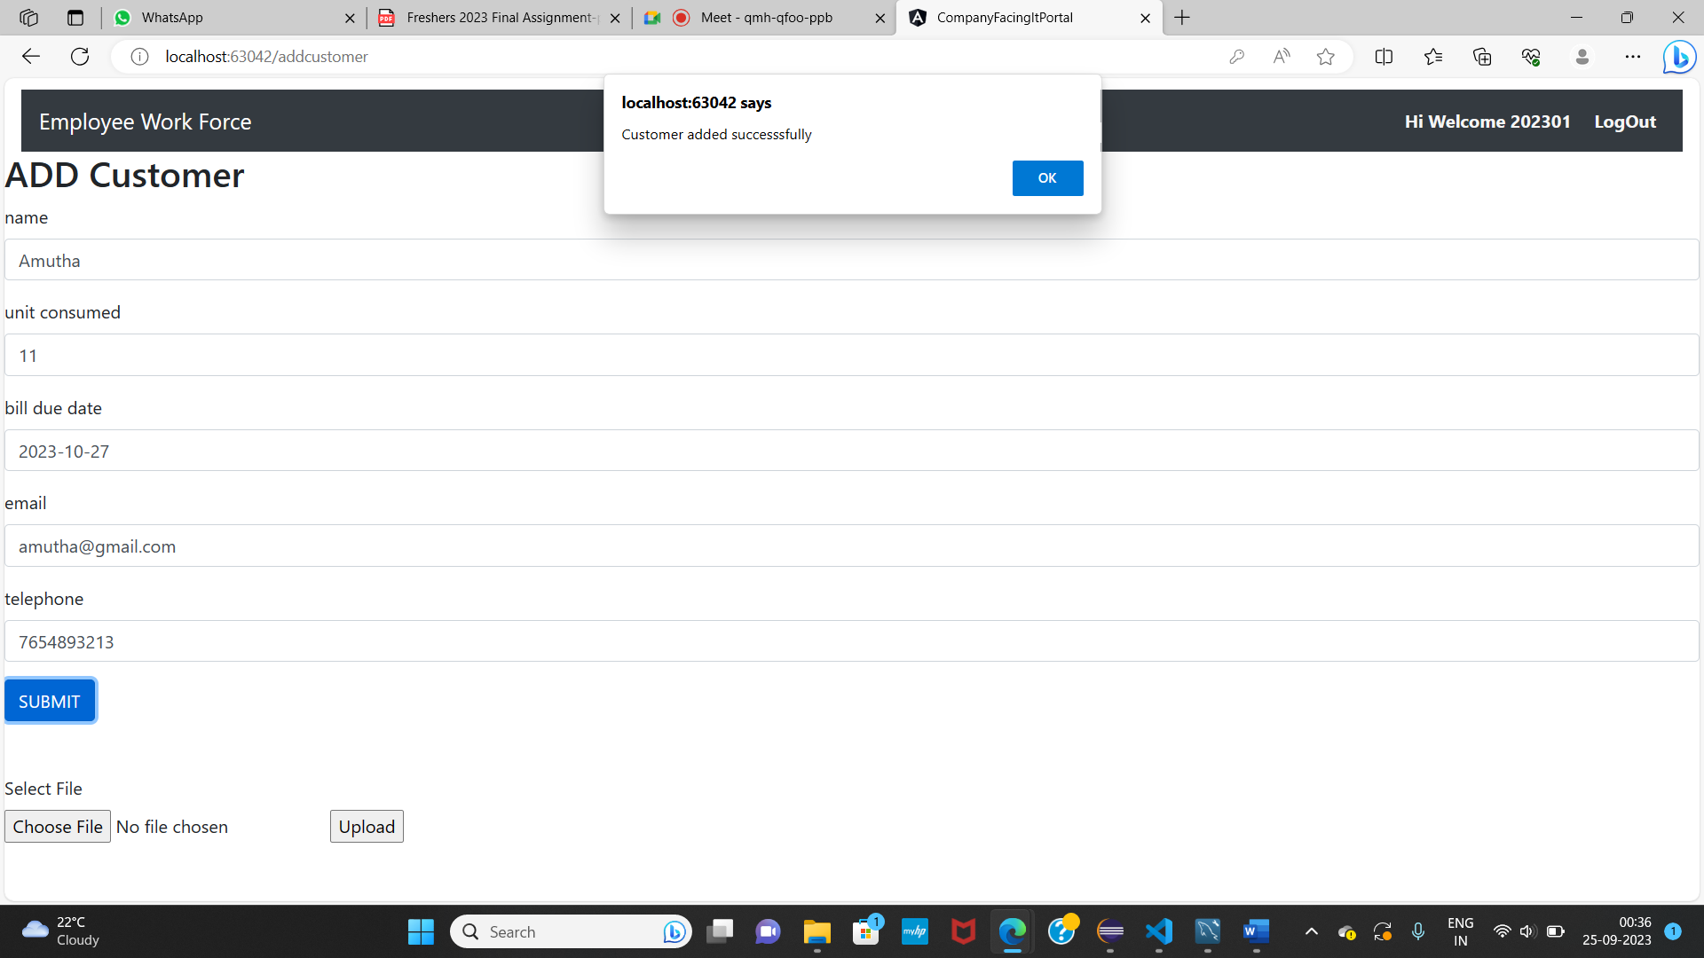

**3) Invoice Generation**

**a. Invoice Generation** - The application automatically generate invoices based on the customer data

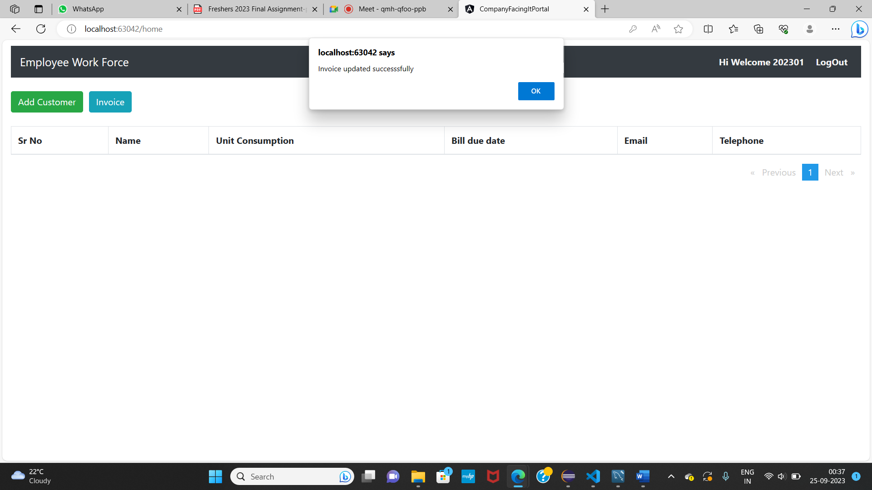

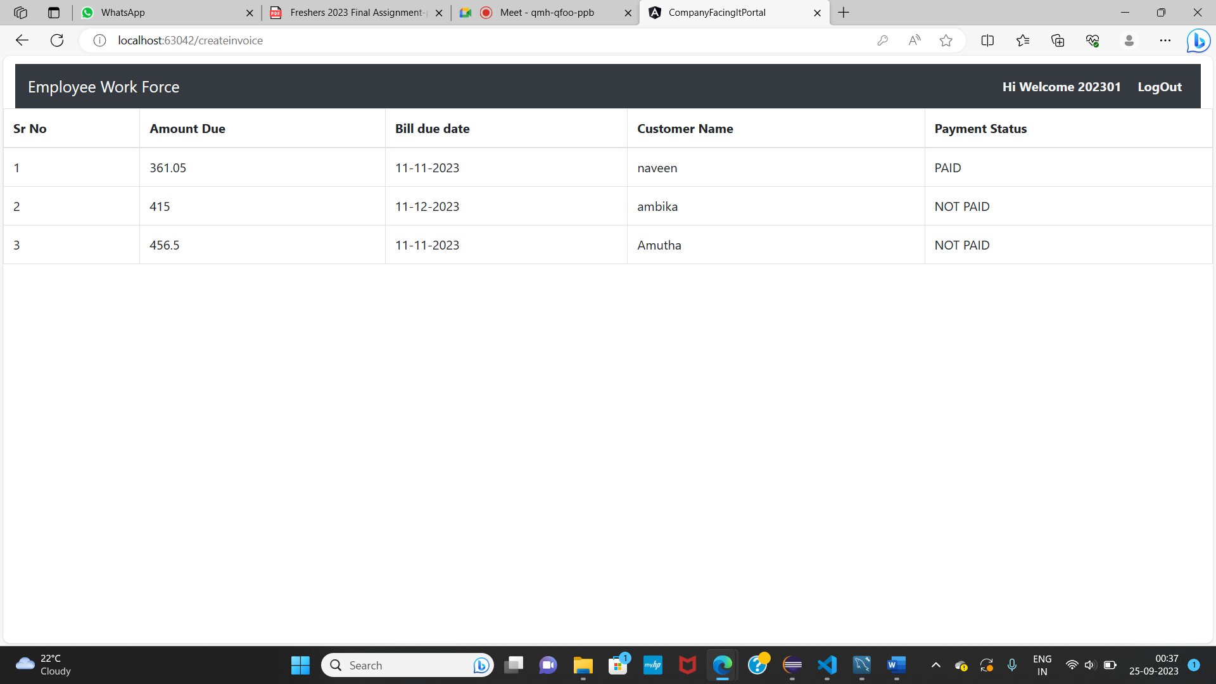

**4) Payment Transaction Tracking**

**Transaction History** - The application maintains all the transaction history for each customer, showing all payment transactions, including the date, amount, and payment method.

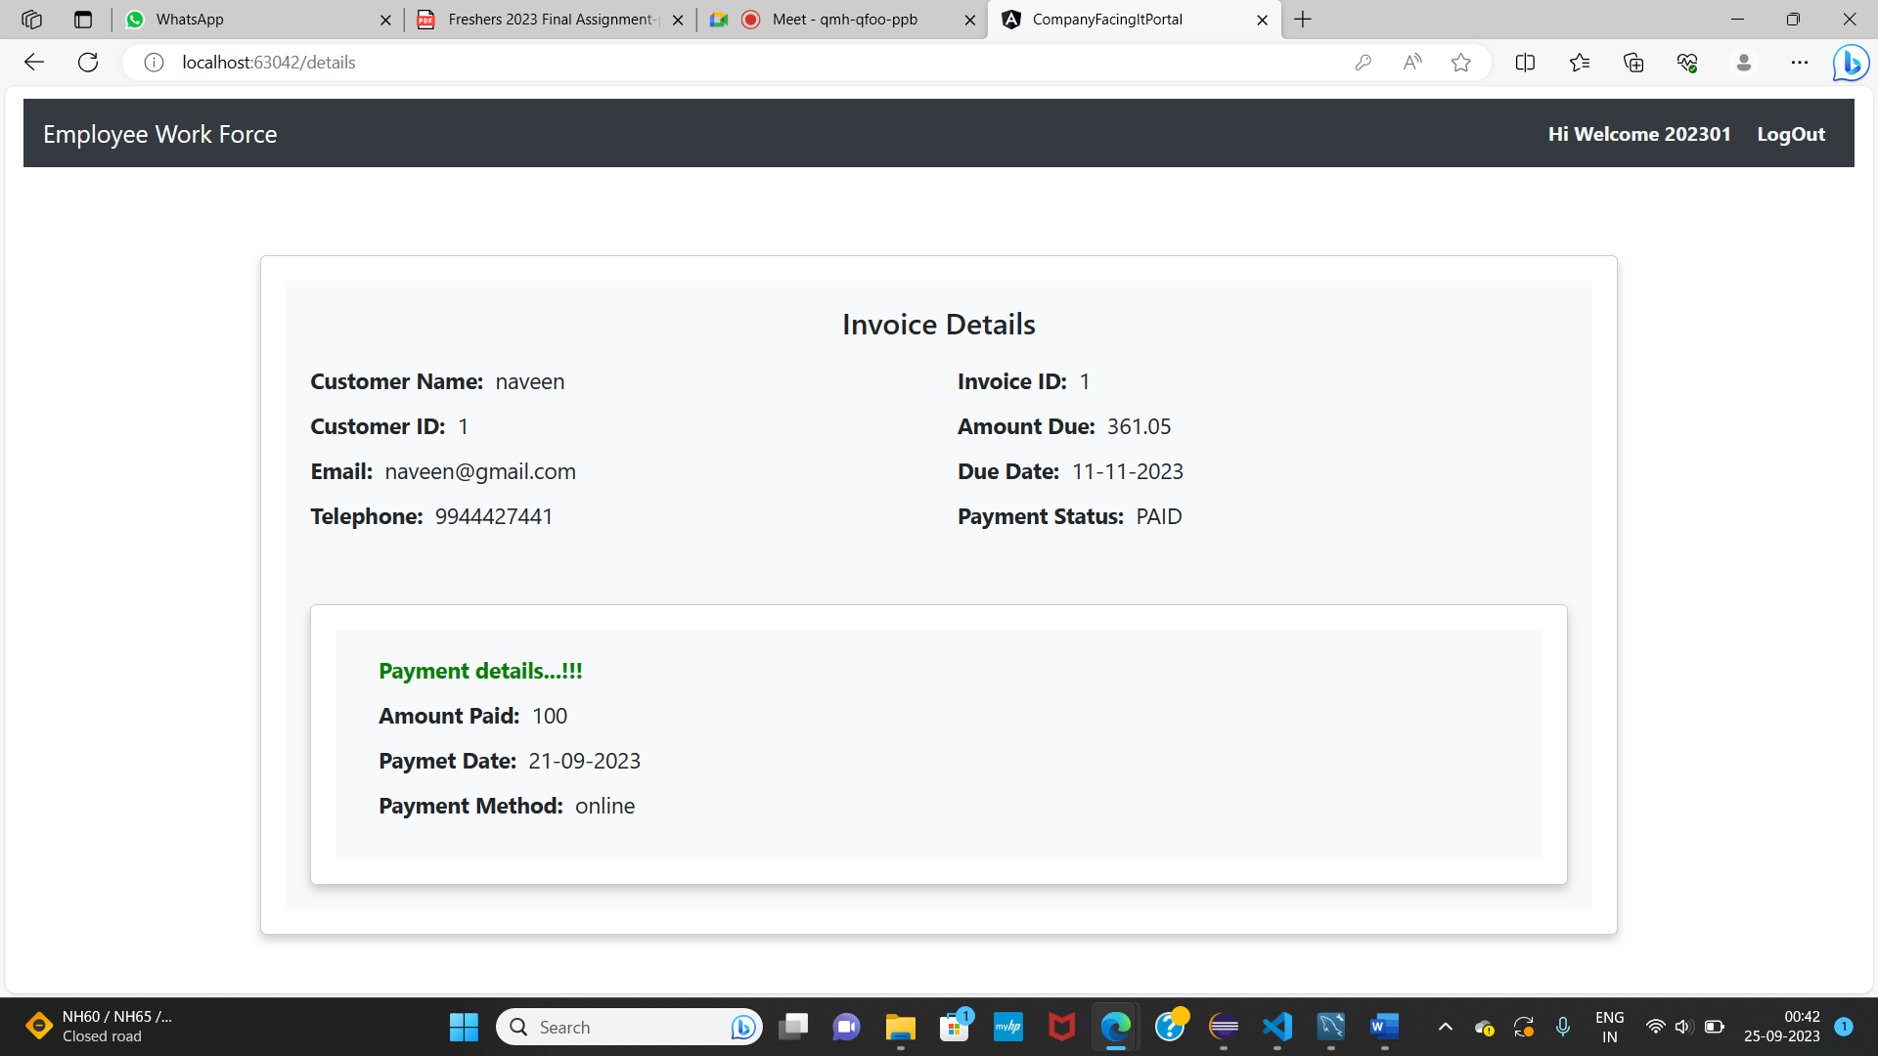

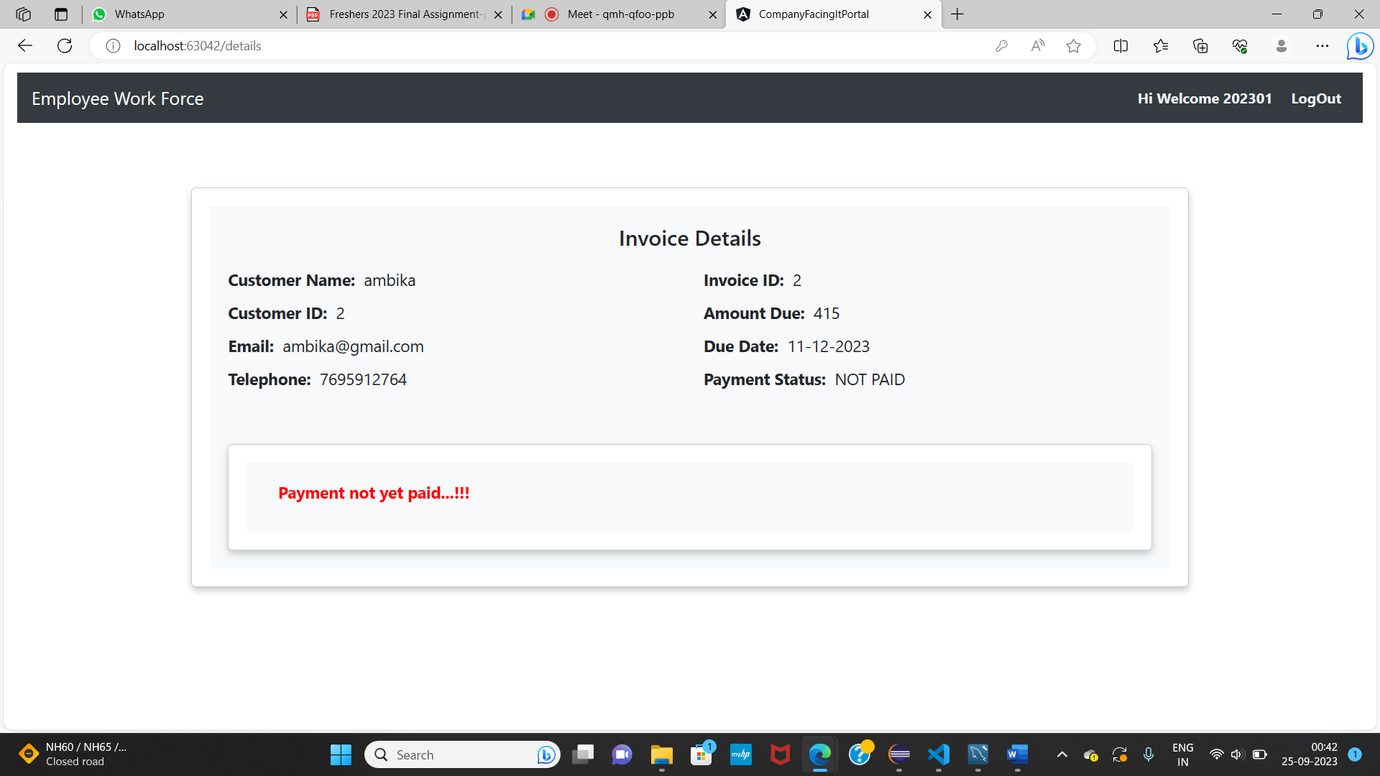

5) Error handling on invalid end point

